Course: CSE 204 – Computer Networks
LAB 7 – ACL and NAT
Due date: June 4th, 2025

Student name | Nguyen Xuan Huan
Student ID | 2131200077

Goal
- Implementing Access Control List
- Implementing Static NAT, Dynamic NAT and PAT

Assignment list
II.1. Access Control List (ACL)
Given a network as shown in the figure below.
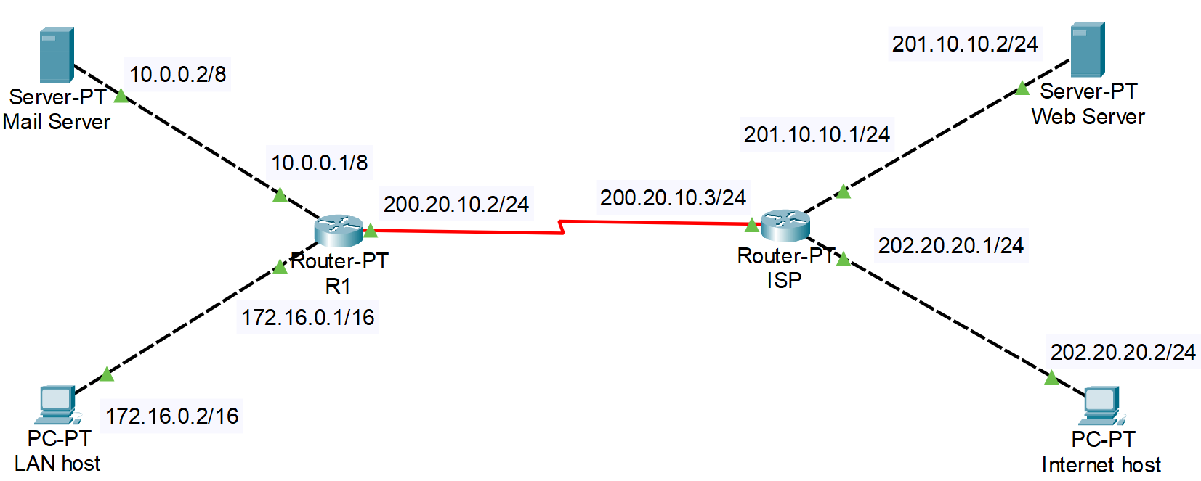
- Config IP address to all Routers and PCs, so that all of them can ping to each other. Show the results of each step:
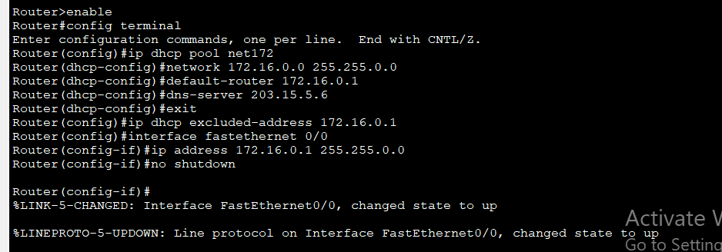
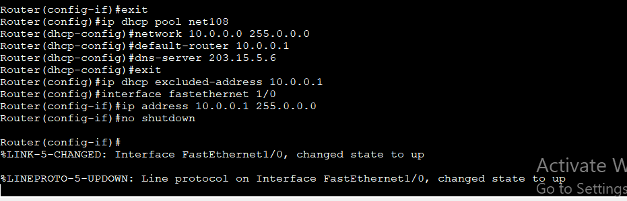
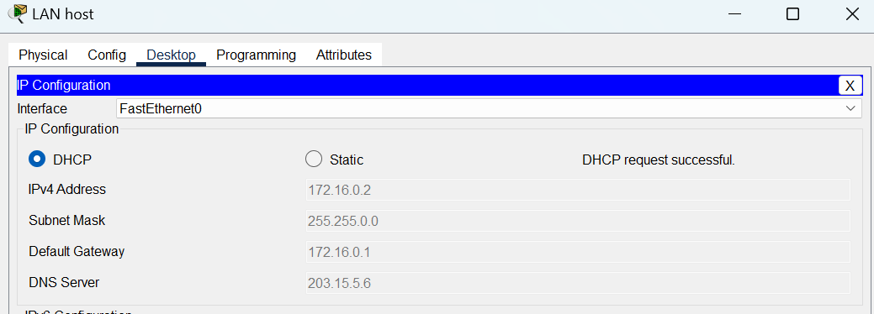
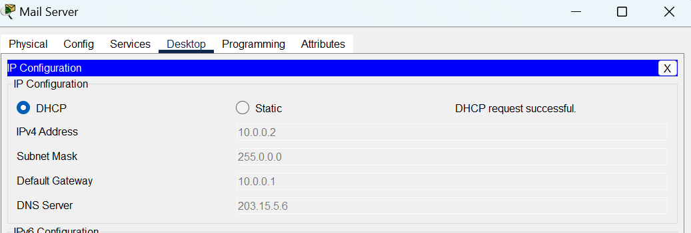
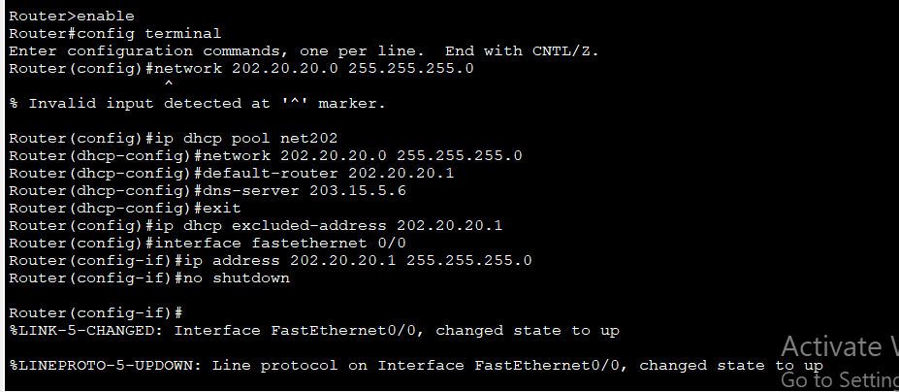
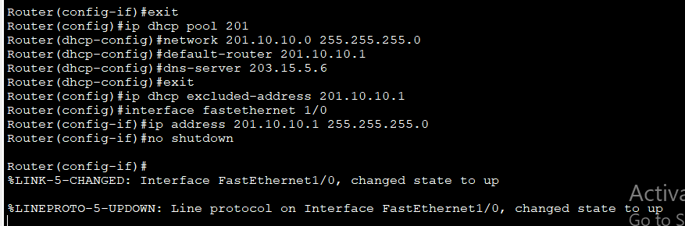
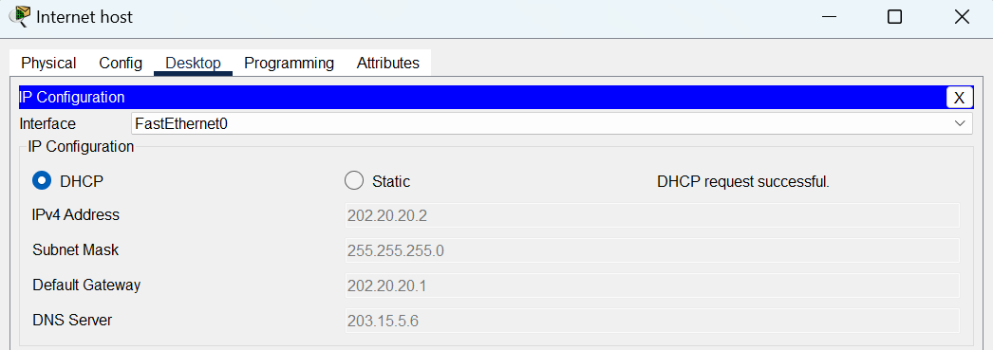
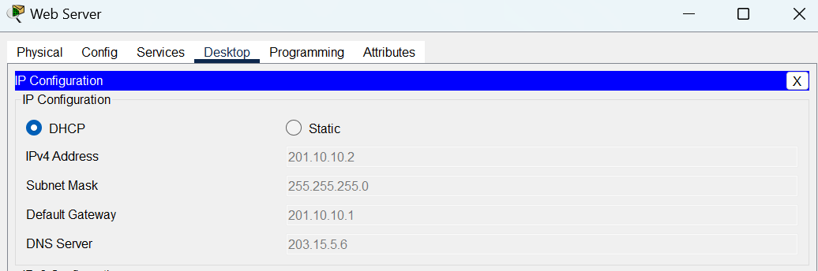
- Configure Routing protocols on 2 routers, so that all hosts and servers can ping to each other. Result:
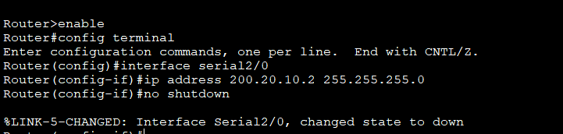
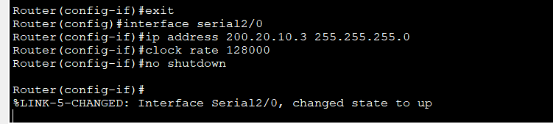
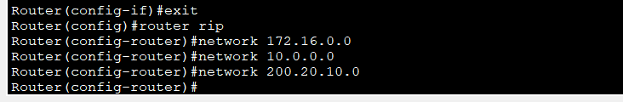
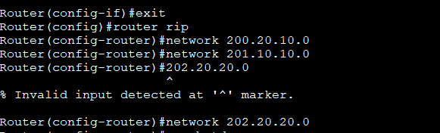
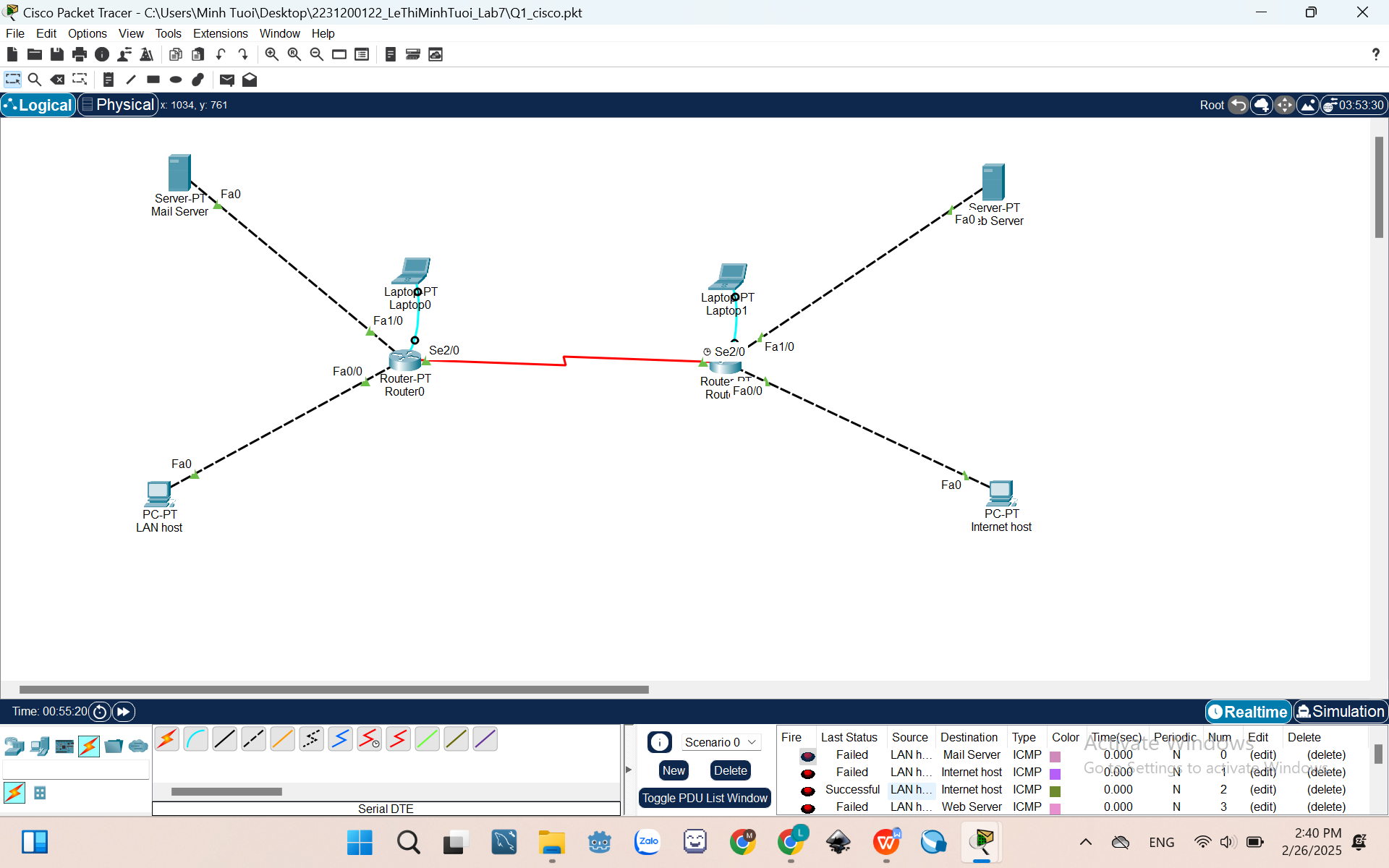
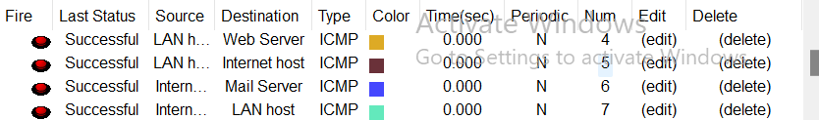
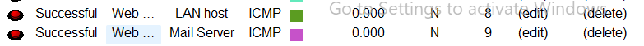
- Configure Access Control List on the Router R1 to make: LAN host CANNOT connect to Router ISP, Internet host and Web Server
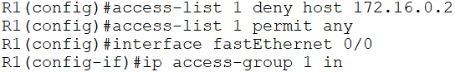
- Result:
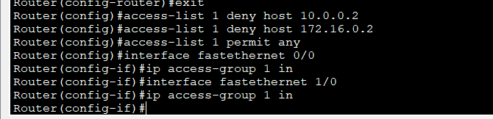
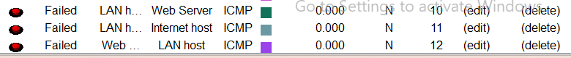
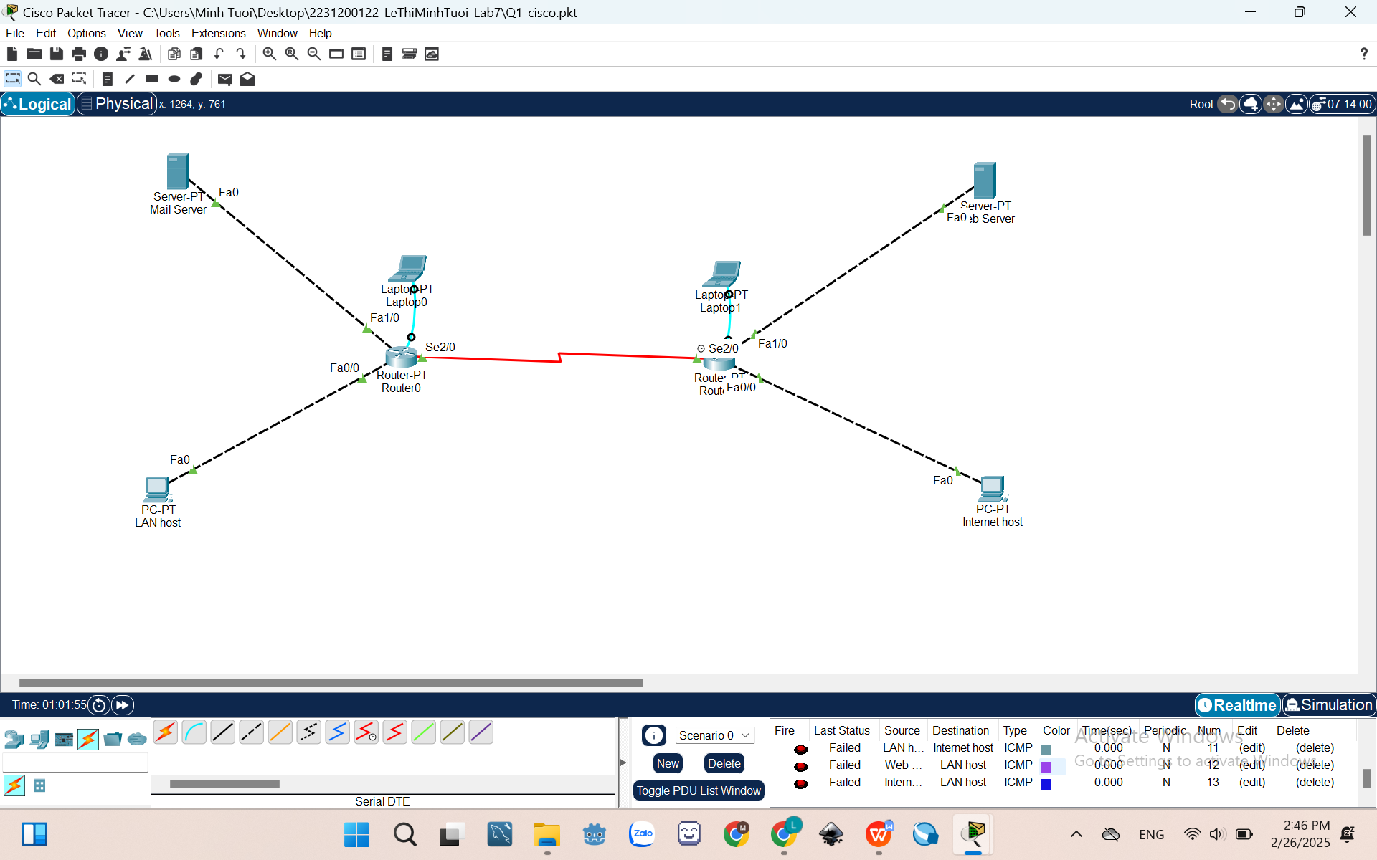
II.2. NAT
- Static NAT
Given a network as shown in the figure below.
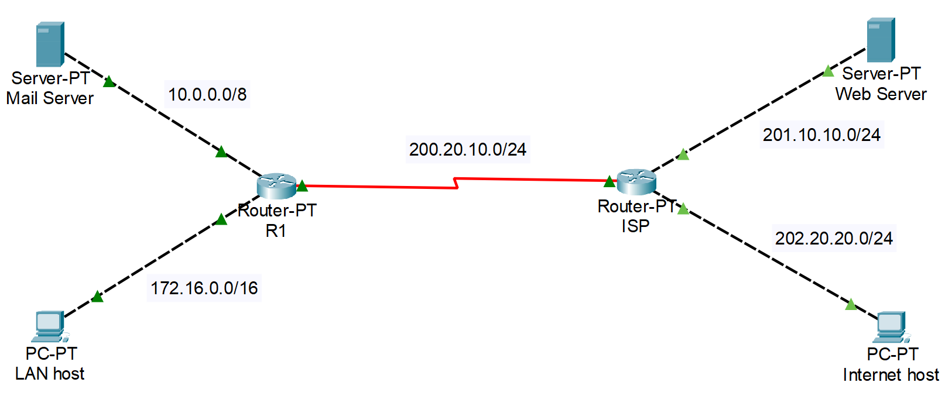
- Config IP address to Routers and PCs. Show the results of each steps:

- Assume that Router R1 can use the public IP address range 199.99.9.0/24. Configure Static NAT on Router R1 to translate IP address of Mail Server to public IP address.
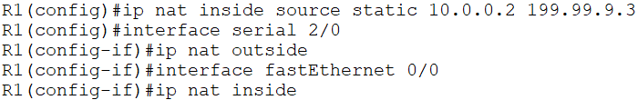
- Configure static routing on router ISP to the NAT address:
ISP(config)#ip route 199.99.9.0 255.255.255.0 200.20.10.2
- Configure default route on router R1:
R1(config)#ip route 0.0.0.0 0.0.0.0 200.20.10.3
- Can Mail Server ping to Web Server (using Command Prompt)? Result:

- Check the IP NAT translation.
R1#show ip nat translations
- Result:
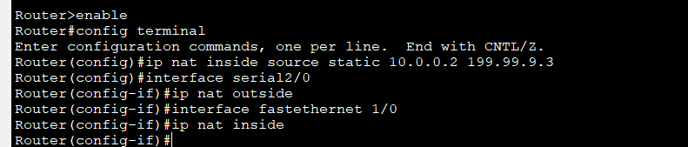
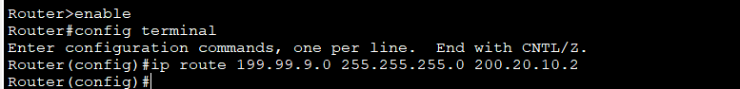
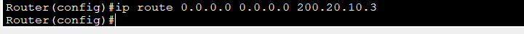
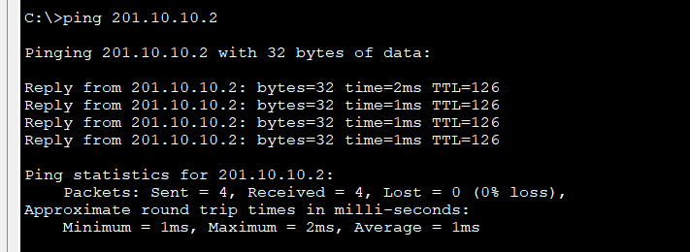
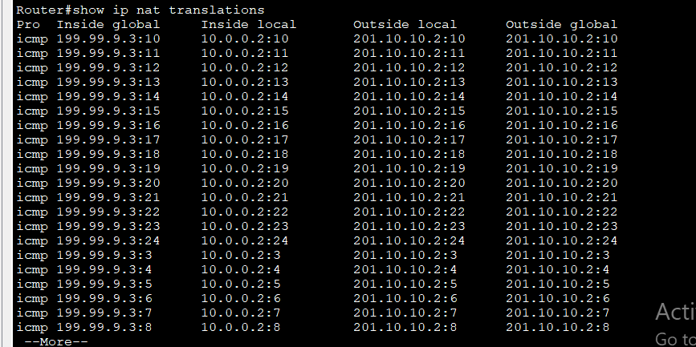
- Dynamic NAT
Given a network as shown in the figure below.
- Config IP address to Routers and PCs. Show the results of each steps:

- Assume that Router R1 can use the IP address range my-pool (199.99.9.40 to 199.99.9.62/27). Configure Dynamic NAT on Router R1 to translate local IP address of Mail Server to my-pool.
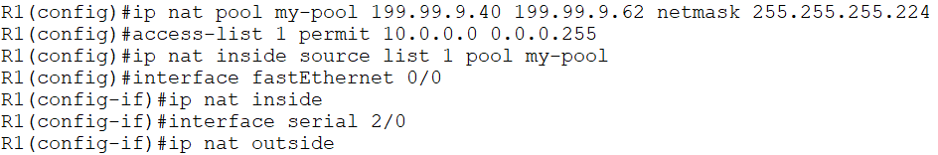
- Configure static routing on router ISP to the NAT address:
ISP(config)#ip route 199.99.9.32 255.255.255.224 200.20.10.2
- Configure default route on router R1:
R1(config)#ip route 0.0.0.0 0.0.0.0 200.20.10.3
- Can Mail Server ping to Web Server (using Command Prompt)? Result:

- Check the IP NAT translation.
R1#show ip nat translations
- Result:
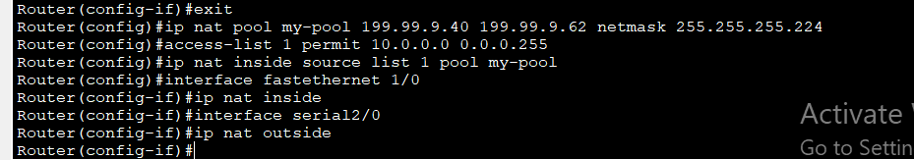
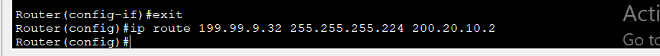
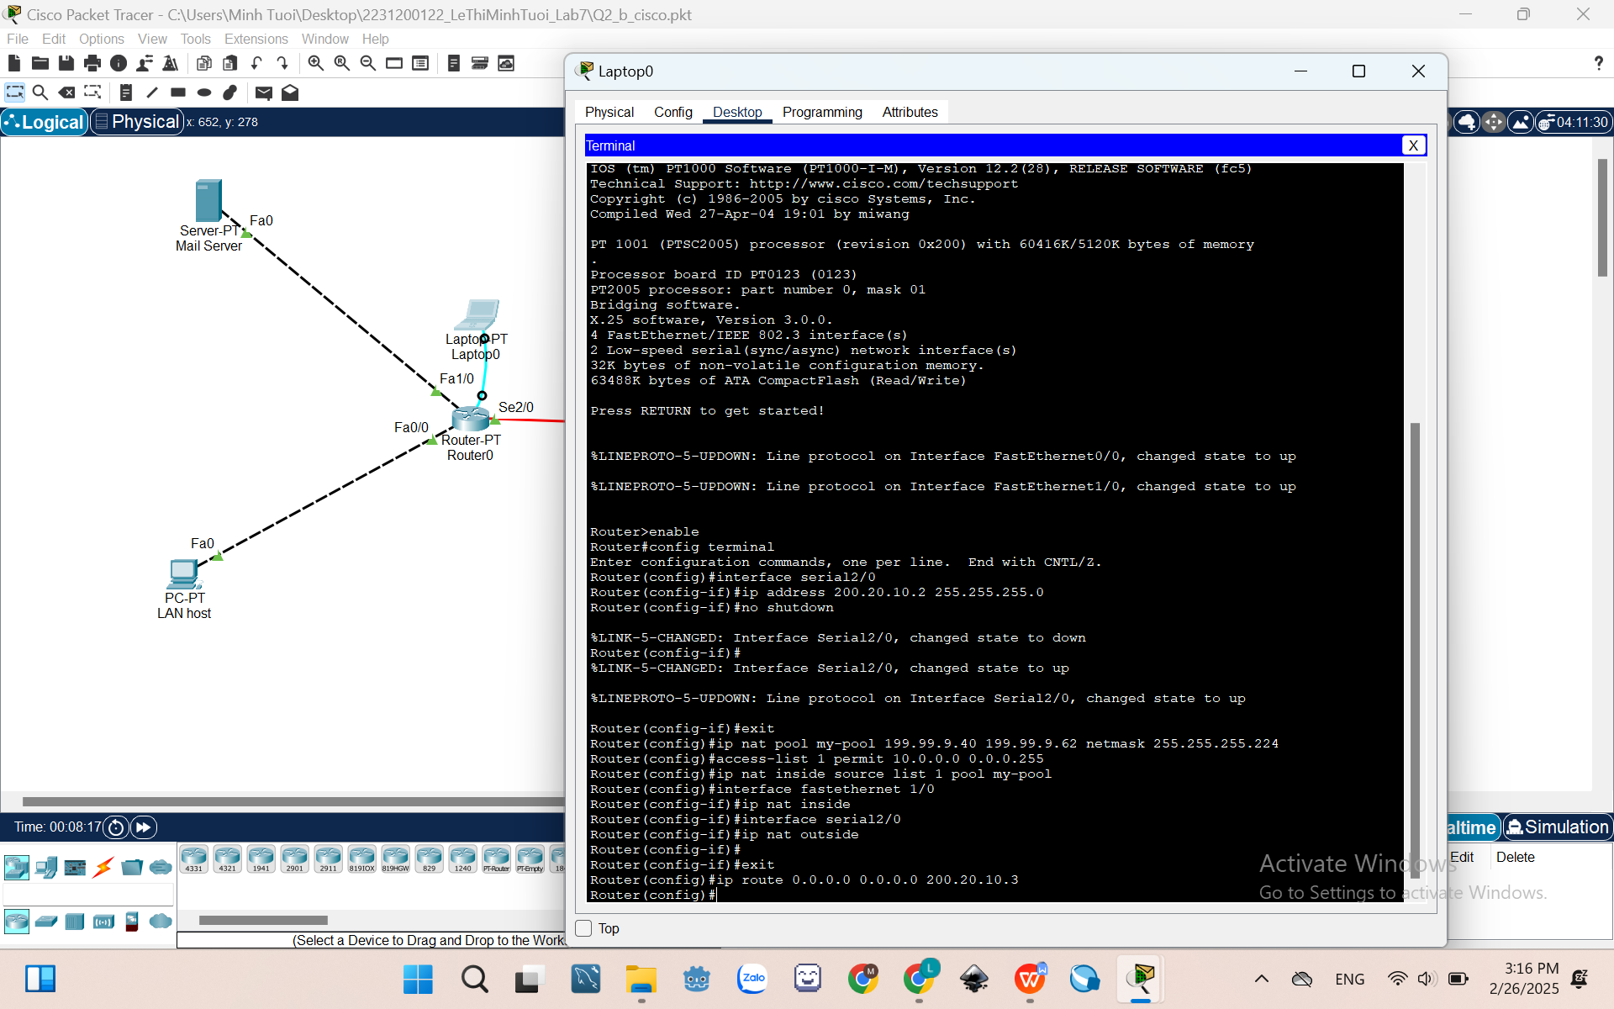
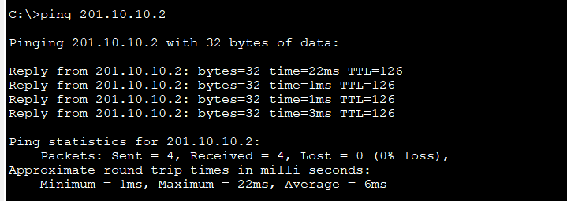
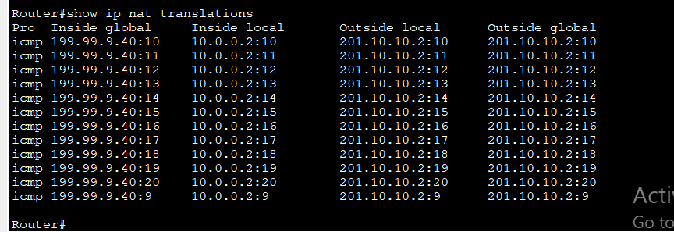
- PAT
Given a network as shown in the figure below.
- Config IP address to Routers and PCs. Show the results of each steps:

- Configure PAT on Router R1 to translate local IP address of Mail Server.
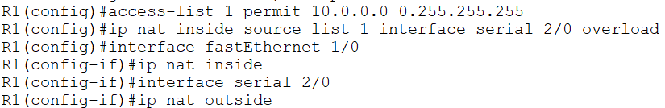
- Configure default route on router R1:
R1(config)#ip route 0.0.0.0 0.0.0.0 200.20.10.3
- Can Mail Server ping to Web Server (using Command Prompt)? Result:

- Check the IP NAT translation.
R1#show ip nat translations
- Result:
